Account-based marketing

What is account-based marketing?
Account-based marketing is an alternative B2B marketing strategy that targets customers who have a particular type of account. It’s a form of segmentation [and in marketing, specificity is always a good thing].

Need account-based marketing examples?
Hotjar is a company that sells website analytics software. They have 3 price points:
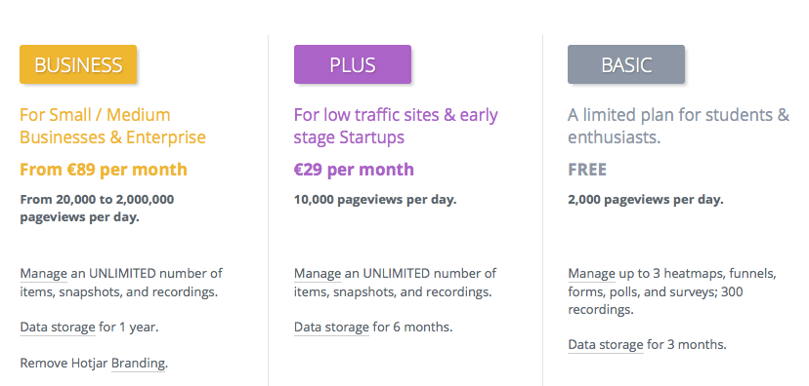

If they wanted to upsell a product to their customers, it makes sense to tailor their messaging according to which version of the software they have.

